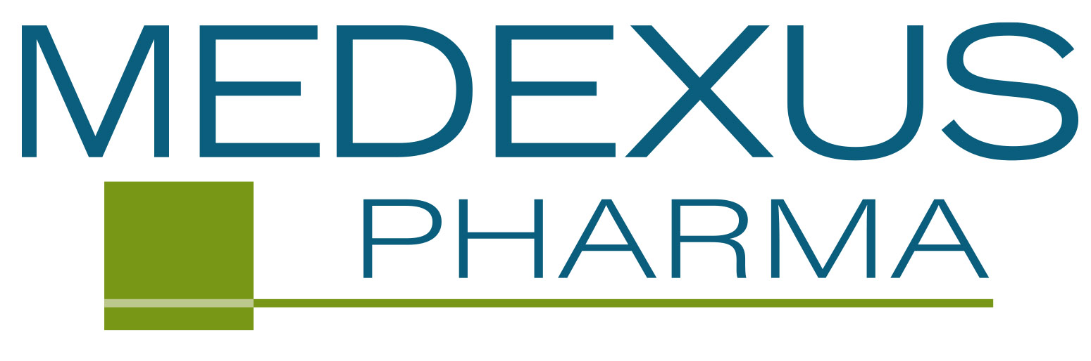

JOB DESCRIPTION

Title: Manager, Hematology Sales Training
Reports To (Title): Vice President Sales
Division: Sales
Job Location: Chicago or Remote
Relocation (Yes/No): No

Summary
The Manager, Hematology Sales Training will be responsible for maximizing sales representative effectiveness by implementing training and development processes and programs that will enhance competencies and productivity and contribute toward the building of a highly effective and profitable total learning sales organization

Roles/Responsibilities
- Schedule and oversee all training programs and identify sales training needs
- Develop training priorities; plan and execute training programs tailored to meet long-term business needs, strategic goals, other targets and anticipated results
- Implement a curriculum focused on product knowledge, selling skills, and sales tools usage for the field sales organization utilizing adult learning techniques and principles
- Development of curriculum for national and regional sales meetings.
- Development and implementation of sales training backgrounders.
- Evaluate, select, and direct vendors and agencies as needed.
- Interact closely with Marketing related to the development and implementation of quality educational programs which support the brand strategy and tactics
- Work collaboratively with the Vice President, Sales and Vice President, Marketing, Regional Sales Directors and/or other team members to identify, recommend, and where appropriate, implement new, creative, innovative learning and development offerings and techniques
- Responsible for new hire initial and advanced training home-study curriculums, live training programs, national/regional sales meetings (covering Medexus product disease states, competitor products, reimbursement and skill/role-based training)
- Assess the effectiveness of training initiatives and facilitation responsibilities, and assists with prioritization of additional training programs
- Conduct regular field visits, working with Regional Sales Directors, Managed Markets Directors, and field-based sales representatives
- Provide field consultation, team and/or individual coaching and development; enabling hands-on learning/development support
- Provide learner feedback to sales management with recommendations for follow-up coaching and training
- Develop and manage the Training Department budget in order to produce cost-effective training programs within allocated resources
- Works closely with Compliance & Quality Assurance to ensure all field-based personnel are up-to-date on all policy and procedure requirements and learning

Qualifications
- Diversified experience in pharmaceutical sales, commercial operations and marketing management
- Must have a combination of excellent organization skills with an ability to interact with your team members and motivate them to succeed
- Will have an understanding of our company objectives and suggest ideas to achieve them through sales training
- Familiar with CRMs (Veeva, SalesForce.com)

Education/Experience
- A Bachelor’s degree is required, MBA or other related graduate-level degree, including a concentration in business, education or science/biology/medicine/pharmacy will be considered a plus
- 3+ years’ experience in Sales Training within pharmaceutical or biotech industry, hematology/oncology experience strongly preferred.
- A minimum of 3 to 5 years previous experience as a successful pharmaceutical sales representative
- Experience defining training goals and objectives
- Strong facilitation skills using multiple mediums
- Strong collaborative experience working cross-functionally with marketing, quality, compliance, regulatory, legal and sales teams.
- Demonstrated experience supporting team members and peers in the field developing skills and abilities
- Strong communications skills
- Business travel by air or car will be required – up to 50%

Updated: April 2022

