

**Monthly Distribution Statement**

April 2021

**Table of Contents**

SECTION I 04

Monthly Certificate Distribution Detail 05

Monthly Cash Source and Uses 06

Monthly Cash Distributions 07

Property Sales This Month 08

Retail Portfolio as of Determination Date 09 – 10

Distribution Center Portfolio as of Determination Date 11

Landlord and Tenant Option Properties as of Determination Date 12

Substitution Properties This Month 13

Monthly Leasing Activity: Distribution Centers 14

Monthly Leasing Activity: Retail Properties 15

Summary Select Financial Information 16

SECTION II – Provided Quarterly 17

Master Lease Retail Tenant Operating Performance for Retail Portfolio as of Determination Date N/A

Master Lease Guarantor Operating Performance N/A

Master Lease Subtenants as of Fiscal Quarter Ended [ ] N/A

SECTION III 18

Management’s Comments 19

Definitions 20

Disclaimer 21

|  |  |
| --- | --- |
| **Trustee**  GLAS Trust Company, LLC  3 Second Street, Suite 206  Jersey City, NJ 07311  Contact: Yana Kislenko  Phone: 201-839-2183  Email: yana.kislenko@glas.agency | **Manager**  Hilco JCP, LLC  5 Revere Drive, Suite 410  Northbrook, IL  Contact: Larry Finger  Phone: 703-244-4588  Email: lfinger@ctltrust.net |

**Forward-Looking Statements & Non-GAAP Presentation**

This distribution statement contains “forward-looking statements” within the meaning of Section 27A of the Securities Act of 1933, as amended, and Section 21E of the Securities Exchange Act of 1934, as amended. These forward-looking statements include, among others, statements of expectations, beliefs, future plans and strategies, anticipated results from operations and developments and other matters that are not historical facts. The forward-looking statements are based on our beliefs as well as on a number of assumptions concerning future events. Readers of these materials are cautioned not to put undue reliance on these forward-looking statements, which are not a guarantee of performance and are subject to a number of uncertainties and other factors that could cause actual events or results to differ materially from those expressed or implied by the forward-looking statements.

Certain of the financial measures presented in this distribution statement are non-GAAP financial measures, other metrics and other information. We believe that non-GAAP financial measures, other metrics and other information provide useful information to investors regarding our financial condition, result of operations and other matters. The non-GAAP financial measures, other metrics and information as presented in this distribution statement may be adjusted in management’s reasonable judgment as appropriate, taking into account a variety of circumstances, facts and conditions. These adjustments may be material and may or may not be specifically identified in footnotes or otherwise. Our measures, metrics and other information (and the methodologies used to derive them) may not be comparable to those used by other companies.

Please refer to Section III of this distribution statement, titled “Disclaimer”, for additional information.

**SECTION I**

**Monthly Certificate Distribution Detail**

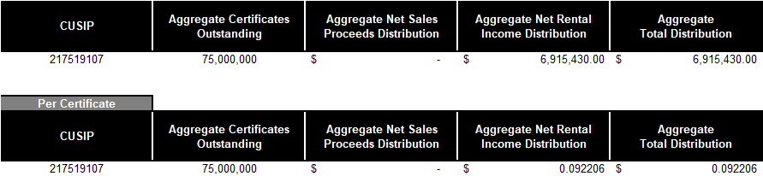

**Monthly Cash Sources and Uses**

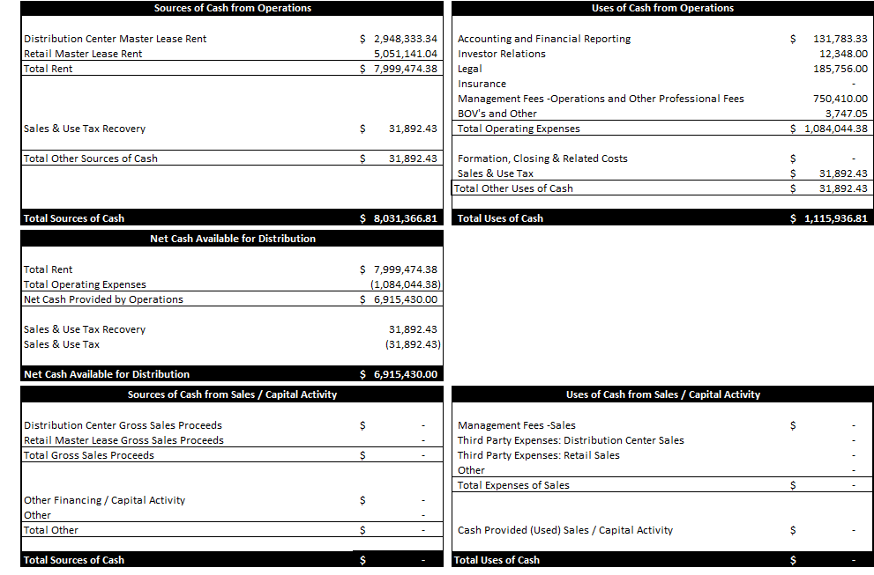

**Monthly Cash Distributions**

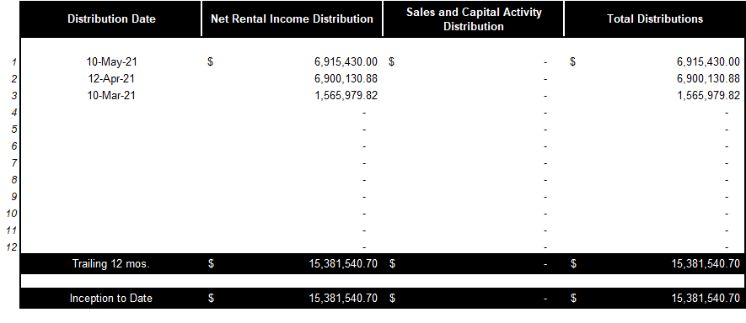

**Property Sales This Month**

**(No Property Sales April 2021)**

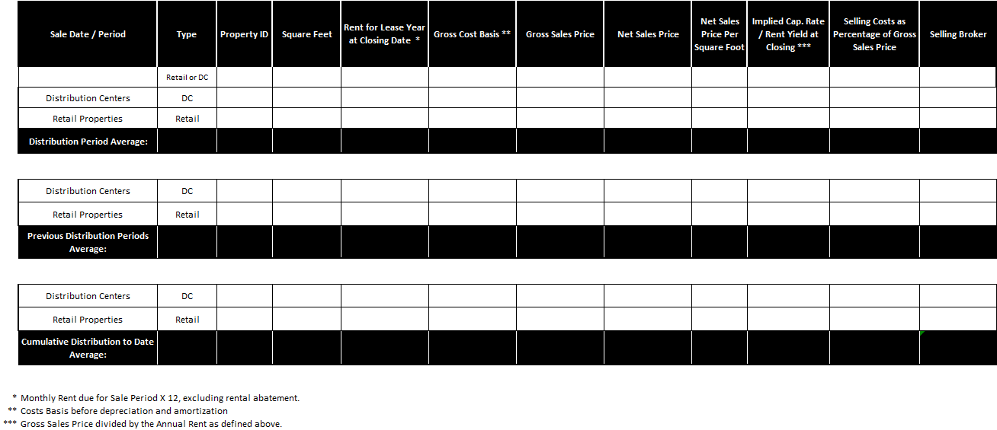

**Retail Portfolio as of Determination Date**

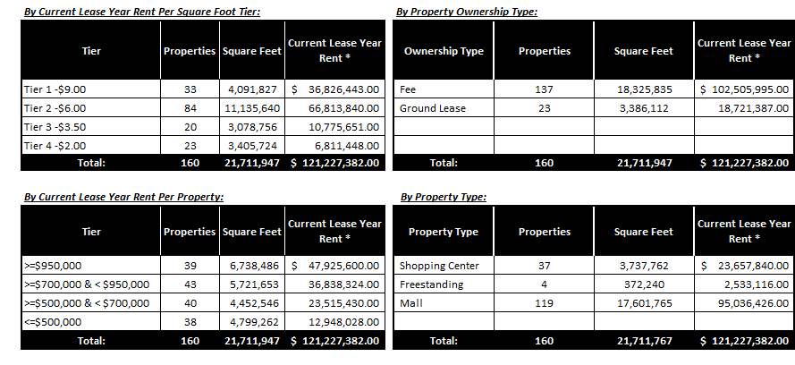



**Retail Portfolio as of Determination Date (Cont’d)**

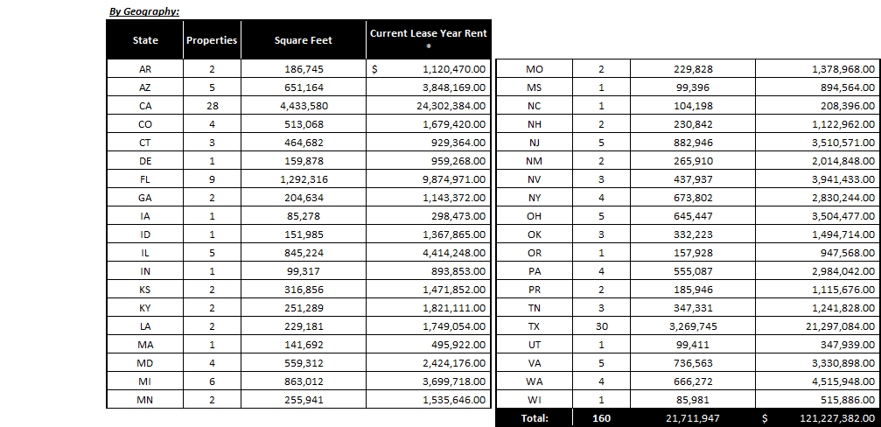



**Distribution Center Portfolio as of Determination Date**

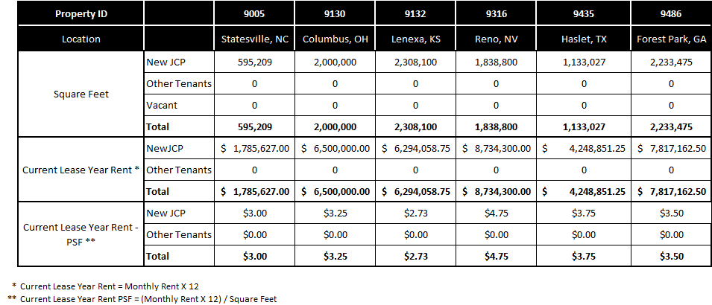

**Landlord and Tenant Option Properties as of Determination Date**

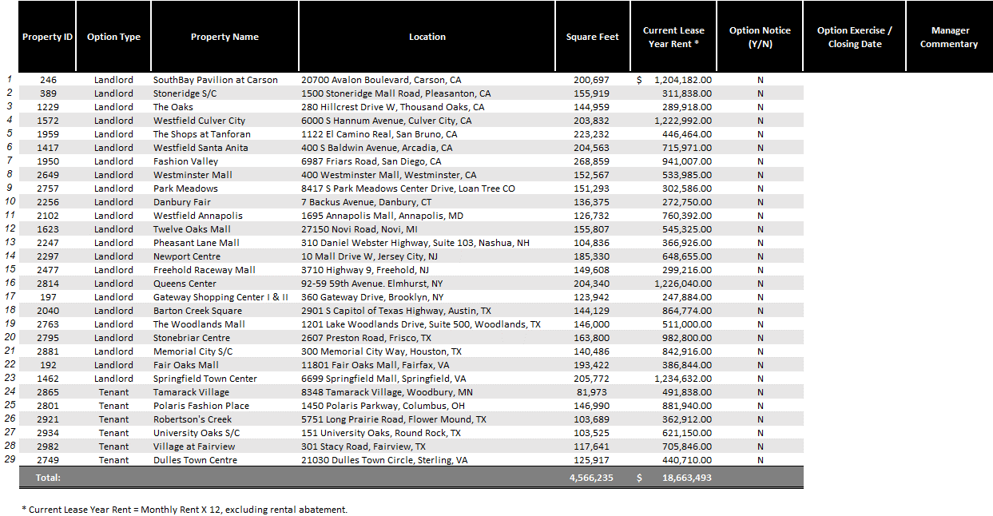

**Substitution Properties as of Determination Date**

**(No Substitution Properties April 2021)**

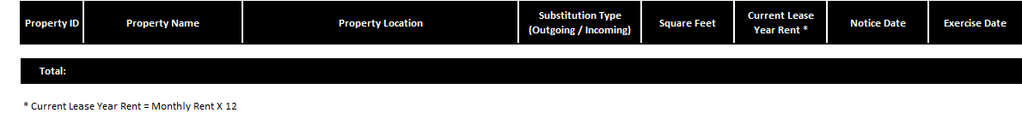

**Monthly Leasing Activity Distribution Centers**

**(No Leasing Activity April 2021)**

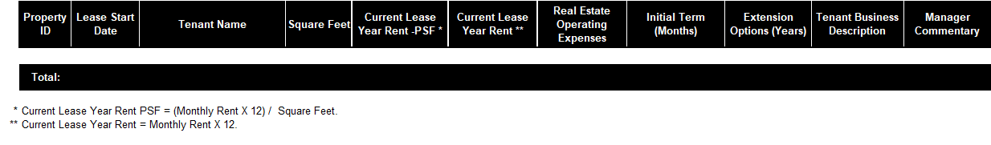

**Monthly Leasing Activity Retail Properties**

**(No Leasing Activity April 2021)**

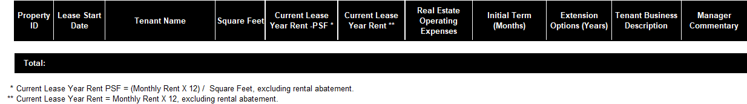

**Financial Information**

For copies of our most recent financial statements, including management’s discussion and analysis of financial condition and results of operations, sales and capital activity, you can access our Annual Report on Form 10-K, Quarterly Reports on Form 10-Q, Current Reports on Form 8-K and amendments to those reports filed or furnished pursuant to Section 13(a) or 15(d) of the Exchange Act at www.ctltrust.net as soon as reasonably practicable after they are filed with, or furnished to, the SEC. You can also review these SEC filings and other information by accessing the SEC’s website at http://www.sec.gov.

The SEC file number is 000-56236.

**SECTION II**

**(Provided Quarterly)**

**SECTION III**

**Management’s Comments**

**(Management Commentary will be provided in our 10Q’s and 10K’s)**

**Monthly Distribution Date Statement**

**Definitions**

**The following metrics apply to Quarterly Reporting only:**

(A) “Tenant’s Sales per Square Foot” is not a measure of the Trust’s financial performance and is provided solely for investors’ informational purposes based on the information that the Trust receives from the Tenant. This measure of operations is derived from sales information reported to the Trust by the Tenant in accordance with the retail master lease and/or distribution center master lease (each, a “Master Lease”), as applicable. The Trust and the Manager do not have the ability to verify the calculation of this information. The calculation of this information by the tenant may be different than how similar measures of operations might be calculated by others. Finally, the Trust is unable to reconcile “Tenant’s Sales per Square Foot” to a comparable GAAP financial measure because no reconciliation is provided for in the applicable Master Lease. Therefore, investors should be cautious about relying upon “Tenant’s Sales per Square Foot.”

(B) “Tenant’s Four-Wall EBITDAR” is not a measure of the Trust’s financial performance and is provided solely for investors’ informational purposes based on the information that the Trust receives from the Tenant. This measure of operations is calculated in accordance with the [Master Lease] and is reported to the Trust by the tenant in accordance therewith. The Trust and the Manager do not have the ability to verify the calculation of this measure of operations. In addition, the calculation of “Tenant’s Four-Wall EBITDAR” in accordance with the applicable Master Lease may be different than how similar measures of operating statistic might be calculated by others. Finally, the Trust is unable to reconcile “Tenant’s Four-Wall EBITDAR” to a comparable GAAP financial measure because no reconciliation is provided for in the applicable Master Lease. Therefore, investors should be cautious about relying upon “Tenant’s Four-Wall EBITDAR.”

**Monthly Distribution Date Statement**

**Disclaimer**

**Forward-Looking Statements:** This distribution statement contains “forward-looking statements” within the meaning of Section 27A of the Securities Act of 1933, as amended, and Section 21E of the Securities Exchange Act of 1934, as amended. These forward-looking statements include, among others, statements of expectations, beliefs, future plans and strategies, anticipated results from operations and developments and other matters that are not historical facts. The forward-looking statements are based on our beliefs as well as on a number of assumptions concerning future events. Readers of these materials are cautioned not to put undue reliance on these forward-looking statements, which are not a guarantee of performance and are subject to a number of uncertainties and other factors that could cause actual events or results to differ materially from those expressed or implied by the forward-looking statements. We do not undertake a duty to update these forward- looking statements, which speak only as of the date on which they are made. The most important factors that could prevent us from achieving the stated goals include, but are not limited to: (a) the severity, duration and geographical scope of the COVID-19 pandemic and the effects of the pandemic and measures intended to prevent its spread on our business, results of operations, cash flows and financial condition, including declines in rental revenues and increases in operating costs in the portfolio, deterioration in the financial conditions of the tenants and their ability to satisfy their payment obligations, increased risk of claims, litigation and regulatory proceedings and the ability of federal, state and local governments to respond to and manage the pandemic effectively; (b) the ability and willingness of the tenants, operators, managers and other third parties to satisfy their obligations under their respective contractual arrangements, including, in some cases, their obligations to indemnify, defend and hold us harmless from and against various claims, litigation and liabilities; (c) the ability of the tenants, operators, borrowers and managers to maintain the financial strength and liquidity necessary to satisfy their respective obligations and liabilities to third parties; (d) macroeconomic conditions such as a disruption of or a lack of access to the capital markets, changes in the debt rating on U.S. government securities, default or delay in payment by the United States of its obligations; (e) the nature and extent of future competition, including new construction in the markets in which the our properties are located; (f) the ability of the tenants, operators and managers, as applicable, to comply with laws, rules and regulations in the operation of the properties; (g) the ability and willingness of the tenants to renew their leases upon expiration of the leases, the ability to reposition our properties on the same or better terms in the event of nonrenewal or in the event the we exercises our right to replace an existing tenant or manager; and (h) the other factors set forth in the our periodic filings with the Securities and Exchange Commission.

**Non-GAAP Presentation:** Certain of the financial measures presented in this distribution statement are non-GAAP financial measures, other metrics and other information. We believe that non-GAAP financial measures, other metrics and other information provide useful information to investors regarding our financial condition, result of operations and other matters. The non-GAAP financial measures, other metrics and information as presented in this distribution statement may be adjusted in management’s reasonable judgment as appropriate, taking into account a variety of circumstances, facts and conditions. These adjustments may be material and may or may not be specifically identified in footnotes or otherwise. Our measures, metrics and other information (and the methodologies used to derive them) may not be comparable to those used by other companies. The foregoing language applies to (and supersedes if different from) the specific definitions contained herein. Readers are cautioned to refer to our periodic filings furnished to or filed with the SEC, including our Annual Report on Form 10-K, Quarterly Reports on Form 10-Q and Current Reports on Form 8-K, which are prepared in accordance with GAAP. This distribution statement and the information contained herein should be reviewed in conjunction with such filings.

**SEC Reporting:** The information in this distribution statement should be read in conjunction with our Annual Report on Form 10-K, Quarterly Reports on Form 10-Q, Current Reports on Form 8-K, our earnings press release dated March 5, 2021 and other information filed with, or furnished to, the SEC. You can access our Annual Report on Form 10-K, Quarterly Reports on Form 10-Q, Current Reports on Form 8-K and amendments to those reports filed or furnished pursuant to Section 13(a) or 15(d) of the Exchange Act at www.ctltrust.net as soon as reasonably practicable after they are filed with, or furnished to, the SEC. You can also review these SEC filings and other information by accessing the SEC’s website at http://www.sec.gov. We routinely post important information on our website at www.ctltrust.net in the “Investors” section, including financial information. We intend to use our website as a means of disclosing material, non-public information and for complying with our disclosure obligations under Regulation FD. Such disclosures will be included on our website under the heading “Investors.” Accordingly, investors should monitor such portion of our website in addition to following our press releases, public conference calls and filings with the SEC. The information on or connected to our website is not, and shall not be deemed to be, a part of, or incorporated into this distribution statement.